**APIs for Enterprise**

**Webinars**

**API360 – A How-to Guide for Enterprise APIs**

CA webinar - <https://www.brighttalk.com/webcast/13425/179089?utm_campaign=channel-feed&utm_content=&utm_source=brighttalk-portal&utm_medium=web&utm_term>

* The business value of APIs – “It’s not what they are, it’s what they enable”
* “It’s not Open Data unless it is Usable Data” – Mike Amundsen
* For enterprises, it becomes more of an optimization exercise

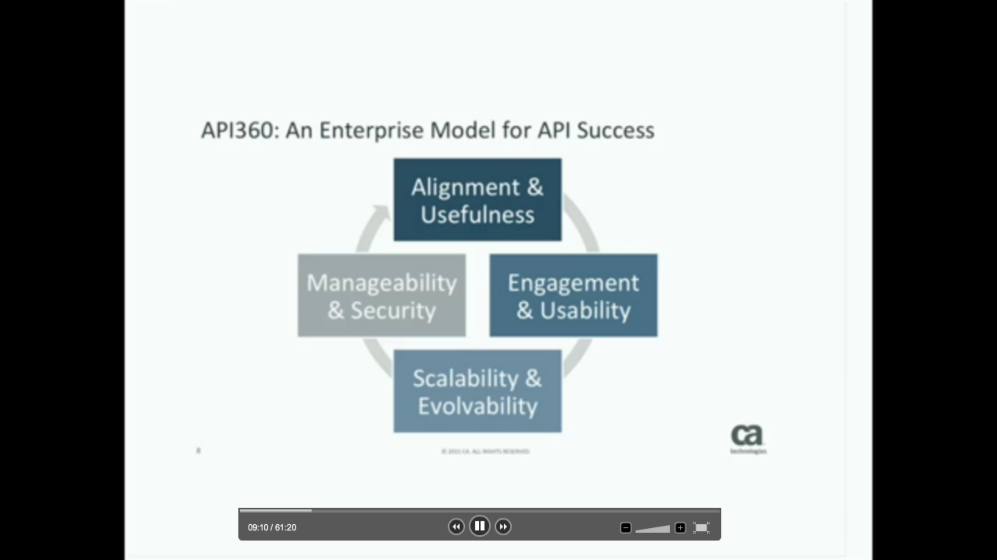

* API360
  + Alignment & Useful – Strategy
  + Engagement and Usability – Still business but more tactical, how to get started
  + Scalability & Evolvability – Architecture
  + Manageability & Security – Operational
* Alignment & Usefulness
  + Alignment & Usefulness
    - A company’s APIs should align with its business goals
    - A company’s should be useful to a target audience
  + API Strategy Anti-Patterns
    - Faith in the Long Trail – For Open APIs, don’t assume that if you build it they will come (make it useful and usable)
    - Service Perfectionism – Don’t start by trying to build the complete set of perfect APIs that will serve every possible consumer (Iterative approach)
    - Technological Obession – Don’t start by picking languages, frameworks and software components. (should be business driven/Project driven rather than solely tech driven)
    - Tunnel Vision – Don’t let single API consumer projects (e.g. mobile) put in long term barriers
  + Successful strategy = Goals + Plan + Execution
    - When you encounter any conflicts down the path of execution, go back to the goals and that in most cases will be a tie-breaker
  + Amazon success: Balance of idealism and pragmatism
    - Whenever they are looking at new features they are not only looking at present, but the value of it in the future
  + Alignment & Usefulness – Key Questions
    - What are my business goals and how can APis help me achieve them?
    - Do I have funded projects that could benefit from APIs?
    - How do I ensure the APIs I enable introduce future value? – think about other possibilities
    - What are the gaps in my industry that can be exploited through APIs?
    - Who are the disruptors in my industry and how are they using APIs?
    - What are some patterns you are seeing in other industries around APIs which will has not been exploited in your own industry?
    - What business model does my API enable or extend? – chances are it is a force multiplier
  + Alignment & Usefulness – Key Deliverables
    - API Roadmap and Project Cross Reference
    - Organizational Model – stake holders
    - Business Models and Business Cases – What value can we create
    - API Academy strategy assessment – CA offering
* Engagement & Usability – focused on Developers
  + Engagement & usability
    - A company should focus on engaging its API client consumers
    - APIs should be easy for these developers to use
  + Case Study: Twilio
    - Key success factor: Focus on Usability
      * APIs do what they need
      * Easy to use
      * Right tooling around it
  + API Usability Metrics – developed by Twilio
    - Developer registrations
    - TTHW (time to hello world)
    - Developer community activity
  + Key Questions
    - Who are the intended and expected consumers of my APIs?
    - Who are the developers that will build clients for my APIs?
    - How do I attract and retain the right consumers and developers?
    - How do I factor my API consumer needs into my API design? (feedback loop)
    - How do I continually enhance the developer experience (DX) for my API?
    - What tools does my developer community need to help them use my API?
  + Key Deliverables
    - Developer Program
    - API and DX Design Principles
    - API Consumer Toolkits
    - API Academy Workshop or Boot Camp – CA Offering
      * Workshop – 1 day event
      * Boot Camp – 3 – 5 days – Apply to your inflight api work
  + API Workshop Design Topics
    - The Principles of API Design
    - Improving API adoption through DX
    - Designing APIs and SDKs for mobile, web and IoT
    - Building Effective API Management teams
* Scalability & Evolvability – How to sustain a good start and build momentum
  + Scalability & Evolveability
    - APIs should be able to shrink and grow with the business
    - APIs should be able to change and adapt over time
  + Good Enterprise Architecture
    - Dos
      * Focus on the horizon
      * Synthesize multiple perspectives
      * Impose appropriate constraints
    - Don’ts
      * Obsess about standardization
      * Only care about technology
      * Favor model over reality
  + Why enterprise initiatives fail
    - Decentralization Vs Centralization Vs Empowerment
  + SOA, APIs and Microservices Architecture
    - SOA – Decompose systems into reusable services, that’s good
    - API – Respect the human element
    - Microservices – Be good at change, be prepared for failure (DevOps/Cont. delivery)
  + Key Questions
    - What factors will affect the design time scalability of my APIs?
    - What about runtime?
    - How should I version my APIs?
    - What are the technology trends I need to consider for my APIs?
    - What are the organizational constraints that will affect my success?
    - How can I leverage my existing assets for APIs?
  + Key Deliverables
    - API Architecture Standards – at the right level – incentive based approach, empower them as against stick approach
    - API Development and Deployment methodology – DevOps culture coming in
    - Technology roadmaps – anything that we build and deploy today will be obsolete in 3 years max – keep those lessons in learning
    - API Academy workshop or Boot camp – CA offering
  + Workshop architectural topics
    - Usable, scalable and evolvable APIs
    - API style selection
    - Managing the lifecycles of APIs
    - Protecting APIs from threats, exploits and attacks
* Manageability & Security – realm of API Management – technology focus
  + Manageability & Security
    - It should be easy to see and control an API’s activity
    - API should give the right data to the right consumer
  + Questions
    - What operational metrics do I need for my APIs?
    - What business metrics do I need for my APIs?
    - Who can I use these metrics to increase business agility?
    - How ca I control access to my APIs without putting up new barriers?
    - Who are the principles involved in my APIs and how can I protect privacy?
    - What are new threats do I need to protect against for my APIs?
  + Deliverables
    - API Analytics & Reporting
    - API Identity and Security model
    - API infrastructure & Operations

API Architectures for the Modern Enterprise

CA Webinar - <https://www.brighttalk.com/webcast/13425/179095?utm_campaign=channel-feed&utm_content=&utm_source=brighttalk-portal&utm_medium=web&utm_term>=

* Digital era – “Age of the customer” – Customer is connected with a smart device
  + Customer is primary stakeholder in all of the enterprise
* Business Drivers
  + Transform the CX – how do you retain the engagement
  + Accelerate your digital business – you can reach out to the customer in all forms and ways (multi-channel)
  + Embracing the Mobile mind shift –
  + Turning big data into business insights
* The Application Economy
  + Application and Identities are the only 2 constant thing
  + The interactions are not
  + APIs connect everything
  + Developer Ecosystem – will be very key in your environment going forward – developers are so empowered and so important (e.g. SFDC.com, force.com),

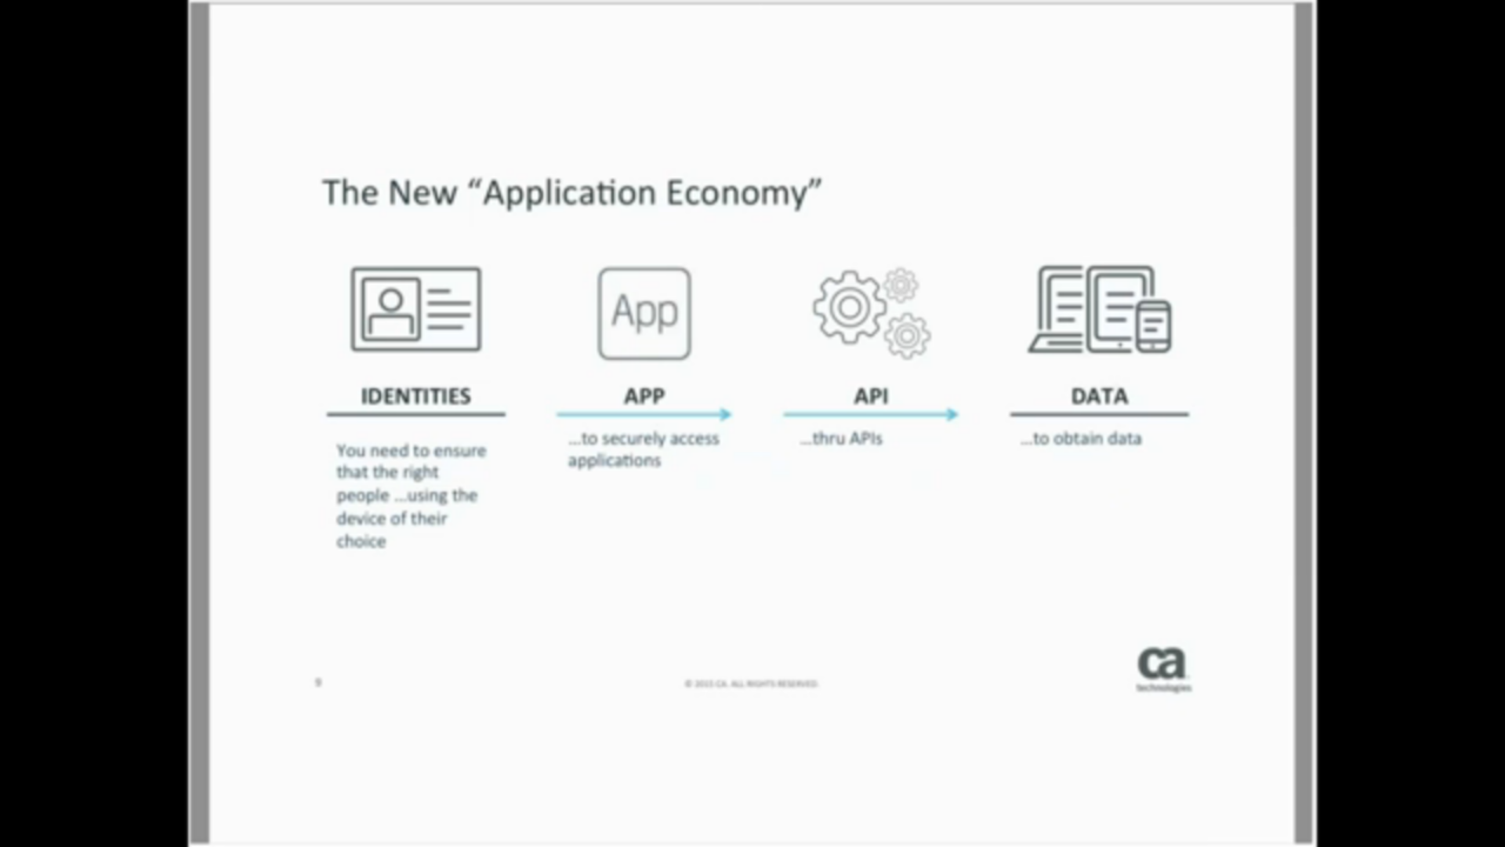

* How do we enable all this
  + Focus on APIs
    - Enable anything, everywhere application access
    - APIs are going to be single entry point (whether external or internally)
* The new enterprise Architects in the digital enterprise
  + Digital Customer Experience Architect
    - Create architecture strategy focused on the customer life cycle
    - Collaborate on digital product and service design
    - Guide customer facing technology choices
  + Digital Operation Excellence Architect
    - Buide integration with ecosystem partners
    - Support innovation with technology and prototyping
    - Co-develop holistic agility strategy

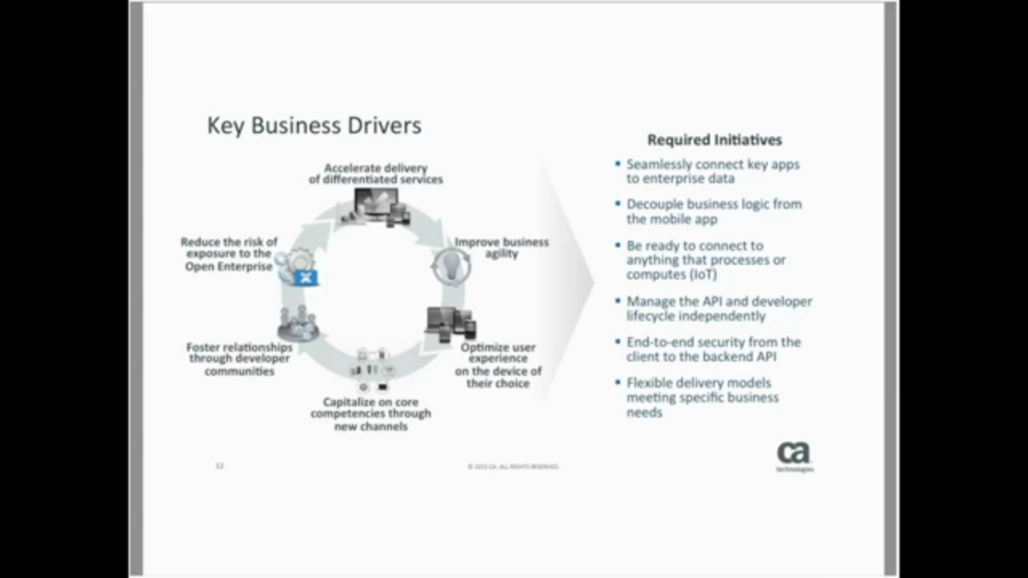

All the above are related to APIs, and how they can independently function

* Weaknesses of legacy integration models
  + Challenges
    - Model originally developed for massive on-premises systems – e.g. SAP
      * No standard data structures (prop)
      * Interfacing also were very custom
      * Need for ESB/Adapter was very important
      * No longer relevant today since most have standard interfaces
    - Integration software in a state of flux due to cloud, mobile, big data and IoT
    - Unable to scale at the speed of internet and needs of mobile/IoT
      * Consumers directly accessing data through millions of mobile devices
      * Security and threat protection
    - Explosion of SaaS applications warrants hundreds of connectors – not scalable or maintainable
      * Looks like need connectors on ESBs
      * Not sustainable to create connectors for each SaaS application
      * Most connectors are just API wrappers – hence is there a need for the connectors?
    - Lack of flexible security models to support internal/external threats
      * ESBs are great for internal connectivity
      * The moment you talk about external consumers or even internal who are geographically disperse
      * Instantly create security policies, becomes important
      * Notion of having a security model which is flexible with the business model becomes very important
* Enteprise Architect’s Perspective
  + “Customers” are not just end users
    - Employees, partners, customers, LOB owners, marketing teams, etc.
  + Competition for budget is a real concern
    - Developers become strong influencers in LOBs/marketing teams investing in its teams
  + Agility is key to success
    - If LOB cannot find what they need internally, they are going to go externally
    - Governance is sometimes looked as a heavy/dirty – not favorably
    - Best governance is invisible governance – do not impose additional constraints, instead enable them (e.g.
  + Security requirements are unprecedented
    - Very real and very mission critical
    - Most of the times pretty simple steps would have prevented major breaches
    - Build-in to your architecture early on
    - Agility brings in new set of security challenges
  + One solution to do it all?
* Use Cases
  + Manufacturing use cases
    - Partner onboarding
      * Bigger challenge for many enterprises
    - Order visibility
    - Mobile enablement
      * Order fulfilment visibility
    - Supply chain automation
      * Not only integrating with core systems, but also the process is very visible – expose APIs
    - Parts fulfilment
    - Inventory
* New Strategies
  + Top EA initiatives
    - Extend legacy systems such as ESB and SOA to support cloud/mobile
    - Implement a single architecture that supports existing infrastructure and embraces the new
    - Integrate all of your digital projects with one platform for manageability
    - Have a flexible future-proof platform to integrate with new technologies and standards
  + What is a “NoESB” architecture?
    - Relatively new term coined last year by Forrester
    - Often misunderstood, but a useful construct when clear
    - An analysis of SOA and API centric architectures
    - Service gateway is most essential runtime component
      * More agile
      * Gateway does ESB functionality
    - What does this meant for existing infrastructure?
    - What if I don’t have an existing infrastructure?
    - What does this mean for future projects?

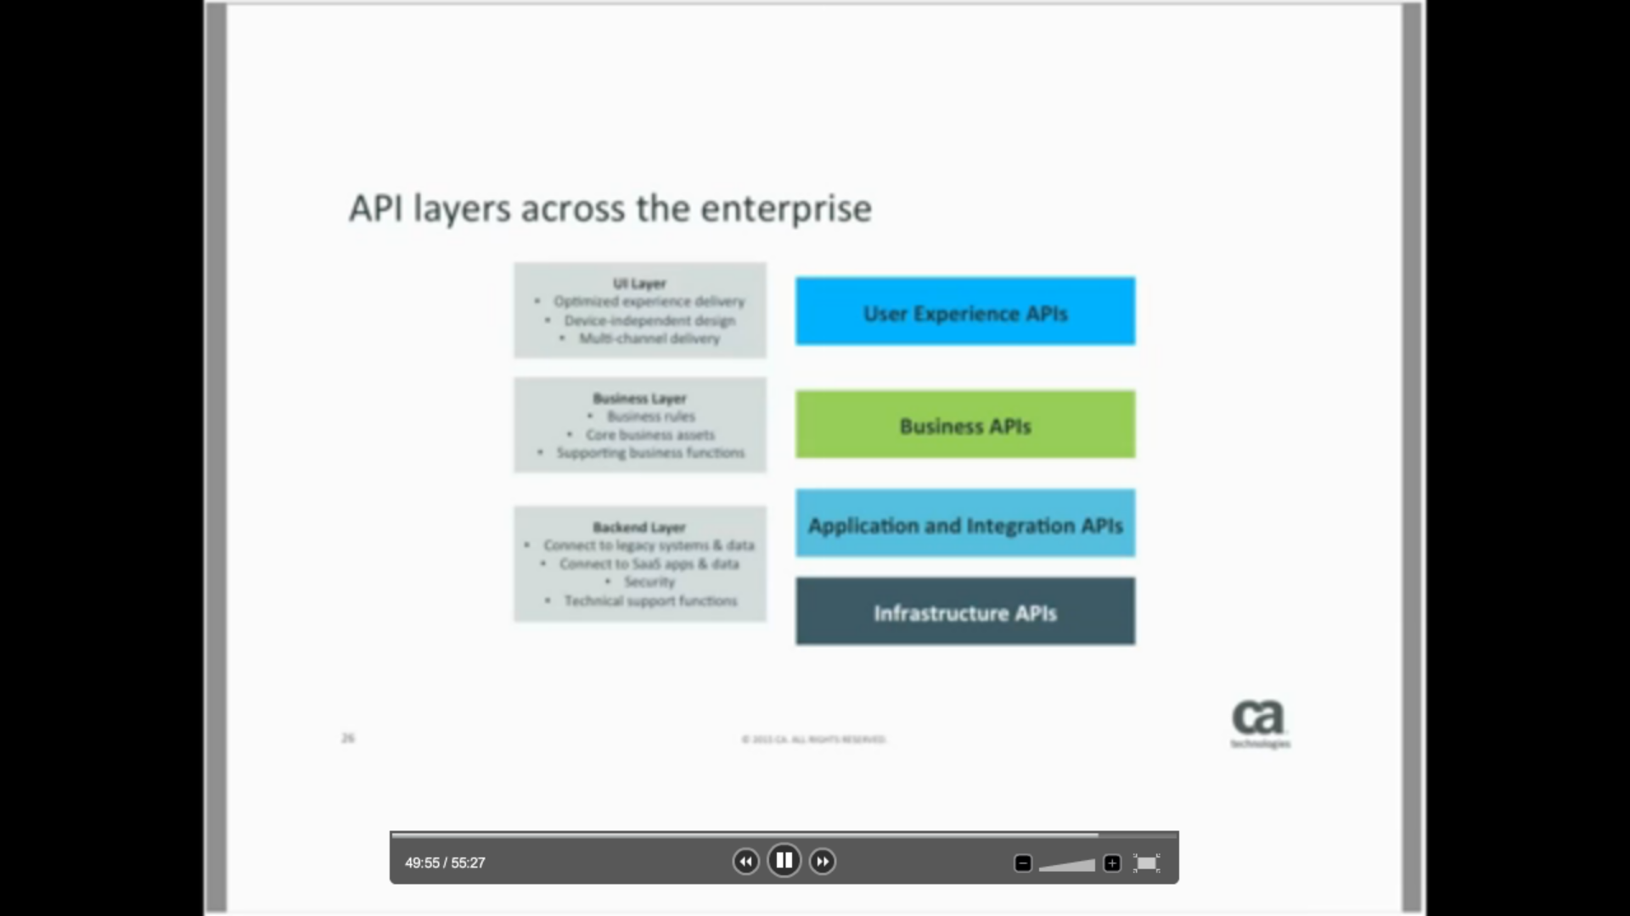

* How do APIs help the EA achive their goals?
  + Bridge legacy architecture with emerging technologies and digital initiatives
  + Allow digital initiative to access data faster and reuse of existing systems without complex hardwired coding
  + Requires a 4 phased approach that we call API360